**PO2EBL_ELECTRIC BLENDER**

**GDD DOCUMENT**

**Version 1.0**

**Draft**

**Document Status**

|  |  |  |  |
| --- | --- | --- | --- |
| **Date** | **Version** | **Document Status** | **Author** |
| 02/26/2020 | 1.0 | Draft | Ali Samir |

1-Document History

|  |  |  |  |
| --- | --- | --- | --- |
| **Version** | **Date** | **Author** | **Change** |
| 1.0 | 01/24/2020 | Ali Samir | Initial Creation |

Contents

**Document Status** 2

Table of figures 4

1 Introduction 5

1.1Project Describtion 5

1.2Block Diagram 5

2 Input Output signals 6

**3** Software features 7

**4** Static Architecture**:** 17

5 APP Components APIs. 17

6 HAL Components APIs.

7 MCAL Components APIs.

Table of figures:

Figure 1 Block Diagram 7

# **1 Introduction**

## 1.1 Project Description

The Electric Blender System is an appliance created by KENOVO. The electric blender system has 3 speeds that can be configured by the user with high safety to avoid system failure caused by unexpected voltage peaks.

## 1.2 Block diagram

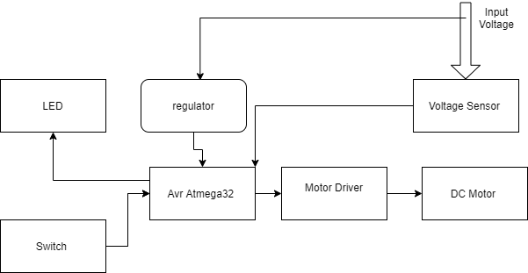

Figure 1 Block Diagram

# **2 Input Output signals**

# **3 Software features**

# **4 Static Architecture**

